Standalone
Bushfire Plan
2020–2021

Contents
1 School details 1
2 Emergency response contact list 2
2.1 Important bushfire emergency information contacts sources 2
3 Incident management team 3
4 Bushfire response telephone tree 5
5 Emergency equipment 6
6 Bushfire preparation checklist 7
7 Bushfire action plan maps 10
7.1 Onsite ‘safer building location(s)’ 10
7.2 Offsite evacuation locations 11
8 Bushfire mitigation management register 12
9 Advice from Department of Fire and Emergency Services and other agencies 13
Appendix A – Bushfire warnings stages 14
Appendix B – Procedures in event of a sudden bushfire 16
Relocate to onsite ‘safer building location(s)’ 16
Offsite evacuation procedures 18
Appendix C - Pre-emptive (planned) closure procedures 20
Flow chart – Principal’s response to ‘catastrophic’ fire danger rating 21
Appendix D – After hours or school holiday procedures 22
Appendix E – Communication templates 23
Emergency text message alert templates 23
School newsletter sample text 24
Sample text for a notice of temporary school closure 25

School details
To complete this plan:
- use the Principal’s guide to bushfire (Principal’s guide) to help you
- on the front cover of the document, remove the word ‘template’ and replace it with your school’s name
- enter information into the grey sections of this document, following the prompts in the square brackets where featured. You can add extra rows to tables where necessary.
When your plan is complete, access Prepare for bushfire season at your school on Ikon to lodge it as one document (include appendices).
School name  (include name of co-located school or facilities if applicable) | Cowaramup Primary School
School address | 24 Waverley Road, Cowaramup
Number of students | 385
Number of staff | 40
Number of students requiring extra support if evacuating | 0
Number of school sides bordered by bush | 2
Names of major roads bordering school | Waverley Road
School’s site-specific alert, for example:  - siren/pause x 3  - continuous handbell  - continuous siren or short whistle blasts | Continuous siren using the megaphone.

Plan prepared by  (principal’s name) | Peter Howse
Date prepared | 29th July, 2020

Emergency response contact list
Enter the contact details into the table below.
Organisation | Details | Phone number / Website
Local police  (eg name of nearest police station) | Margaret River Police | 97572222
Local hospital  (eg name of nearest hospital or medical emergency facility) | Margaret River Hospital | 97570400
Local fire brigade  (eg name of nearest fire station) | Margaret River Fire Brigade  Cowaramup Bush Fire Brigade | 97572738
Bus contractors  (ready for pre-emptive closure or offsite evacuation) | Shepardson’s Bus Contractors | 97572955
Electricity provider - in the case of a power outage  (eg Horizon Power or Western Power) | Western Power | 131351
State emergency service (if known) | Margaret River | 132500  1300657209  97573000
Poisons information (where relevant) |  | 131126
Regional Executive Director – contact name | Neil Milligan  Alison Ramm | 0428913870  0438924649

Dial 000 in an EMERGENCY

Other important emergency sources

- Emergency WA website - https://www.emergency.wa.gov.au/

- Department of Fire and Emergency Services
Information line – 13 33 37
Twitter - https://twitter.com/dfes_wa

- Local radio
- ABC Emergency WA
- ABC local radio
- 6PR

Incident management team

Position | Staff Name | Duties | Mobile number
Principal | Peter Howse | Monitor official communication channels to enable informed decisions to be made.  Initiate Emergency Response Contact List  Raise alarm throughout school (siren and megaphone)  Complete sweep of school including toilets, sheds and outside areas to make sure that everyone is in a designated safer building location.  Take copies of all class lists, DOTT timetable, EA timetable and Library Timetable.  Monitor situation and ensure that classes stay in designated ‘safer building locations’ (ref: appendix C)  Liase with fire wardens, DFES and emergency services.  Advise Regional Director Schools. | 0409117605
Deputy principal | Amanda Rodda  Debra Niotakis | Assist principal with sweep of school including toilets, sheds and outside areas.  Take copies of all class lists, DOTT timetable, EA timetable and Library Timetable.  Take asthma medication (lunchboxes) to redblock. | 0450045644  0427478387
Manager corporate services  School Officer | Julie Ryan  Corien Ridley  Nichelle Dodd  Tracey Taylor | MANAGER OF CORPORATE SERVICES  Call 000  Collect first-aid kit (red backpack) with asthma puffer and take to library.  Communicate with bus contractor & DoE media unit  Remain in building unless otherwise directed by fire warden.  SCHOOL OFFICER:  Put asthma medication from sick bay in bag (lunchboxes with plans) and give to Deputy to take to red block when doing sweep.  Advise parents via School Bag App.  Close doors, roof vents and windows.  Turn off evaporative coolers.  Check off all visitors that return to office and check off against the visitors Ipad Sign in.  Remain in building unless otherwise directed by fire warden. | 0408957420  0427573842  0418933788  0409602779
Teachers |  | Remain with class and support staff.  Move to a ‘Safer Building Location’  Red Block  Rooms 5,6,7,8,10,11, Art Room  Library  Room 9, K1-K3, PP1, PP2, Theatre, Canteen staff  Stay within Rooms  Rooms 1,2,3,4  Account for each child (roll) and identify students and support staff with known respiratory conditions. Close doors, roof vents and windows.  Turn off evaporative coolers.  Remain in building unless otherwise directed by fire warden.
Accredited first aid officers

CLEANERS, GARDENERS and CHAPLAIN |  | Report to the administration building so you can be marked as present
VISITORS |  | All visitors must report to the administration building so they can be marked as present in Visitors’ Book.
Teacher Max Alcock 0400 469 762
Cleaner Anna Bona 0438 935 326
Cleaner Linda Briggs 0439 389 475
EA Angela Brown 0409 087 122
EA Denise Clarke 0428 883 353
Teacher Sandra Collins 0438 404 178
Teacher Joanne Curtin 0428 284 041
Gardener Tony Calder 0407980362
Teacher Maddison Gaines 0416 586 468
Teacher Sarah Otto 0403 656 027
EA Penny Hepburn 0437 417 674
Teacher Jemma Hopkins 0428 107 117
Teacher Barbara Land 0417 985 363
Teacher Leesa Mathers 0402 283 723
Teacher Erin O'Neill 0449 147 195
Teacher Natalie Oxbrow 0417 096 712
Teacher Janice Fox 0426846365
Teacher Amanda Podvrsnik 0448 726 534
Teacher Vans Walley 0410 527 301
EA Alison Skinner 0448 927 664
EA Lisa Tassell 0410 021 335
Teacher Susan Trott 0428 358 816
Teacher Zac Yorke 0404 380 399
Teacher Demelza Franklin 0418 913 209
Teacher Jane Taylor 0417 916 330
Teacher Kristy McKinley 0419 958 285
Teacher Sonya Lees 0415 469677
Teachers Jalina Khan 0424040627
Cleaner Tom McCaughley 0422093865
Cleaner Casey McCaughley 0422093865

Bushfire response telephone tree
Complete the information boxes with the contact details for the relevant stakeholders.
Parents
Send emergency App Notifications and email templates to notify
Neighbouring schools:
Augusta Primary
97815100
Myles Rees
0438 994 971
Margaret River Primary School School
Aaron Thomas
9757 8500
Margaret River SHS
9757 0700
Andrew Host
Rapids Landing PS
Lisa Helinus
97578200

Manager corporate services
Julie Ryan
0408957420
Corien Ridley
0427573842
Deputy principal
Amanda Rodda
0450045644
Debra Niotakis
0427478387
Regional executive director
Name: Neil Milligan
Mobile: 0428913870

Name: Alison Ramm
Mobile: 0438924649
Department
Security Unit
T: (08) 92644632
Media Unit
T: (08) 9264 5821

School board
Narelle Rodley
0417951200
Coordinator regional operations
Name: Andrew Grono
Mobile:0434002780
Staff
Send emergency notification if school is closed

Emergency response contact list
(refer to Section 2)
Buses
Shepardsons
97572955
Canteen
Lainy Mammone
0400555296
Out-of-hours childcare
Cowaramup Childcare
97559801
:
Principal
Peter Howse
0409117605
SMS
sMSSMS

Emergency equipment
Identify the location and the type of emergency equipment at your site.
Equipment | Details  (include location/s, date checked and any other comments)
Evacuation kit | Admin Checked July 2020
First aid kit(s) | Admin Sick Room checked at the commencement of each term.
Emergency warning or alert system, eg:  - mobile telephones (charged)  - hand-operated fire alarm (portable siren)  - portable radios  - spare batteries | Admin Checked July 2020
Emergency communications equipment | All staff to take mobile phones
Registers for:  - students  - staff  - visitors | Use of Ipad – Allows remote access of visitor register off site.

Bushfire preparation checklist
Principals must:
- complete this bushfire preparation checklist annually
- provide evidence in the form of notes to show that management activities have been actioned
- inform all staff members of their responsibilities.

Management activities | ☑ or NA | Evidence
The annual review of the Standalone bushfire plan has been completed before the start of bushfire season. | ☑ | July 2020
Consulted and received advice in preparing your Standalone bushfire plan from any of the below (as relevant):  - local Emergency Services  - Department of Fire and Emergency Services  - Department of Biodiversity, Conservation and Attractions – Parks and Wildlife Service  - local volunteer fire brigade  - WA Police Force  - local government local emergency management committee or local government representative  - community emergency services manager if there is one for the area. | ☑ | [complete section 9]
Staff have been made aware of the Standalone bushfire plan through:  - staff meetings  - staff bushfire induction session that includes:  - an overview of the Standalone bushfire plan  - how to turn off evaporative air conditioner units, the location of switches  - how to close roof vents  - the types of Bushfire Warnings issued by the Department of Fire and Emergency Services and the Emergency Alert telephone warning system  - to direct bushfire media enquiries to the Department’s media unit (08) 9264 5821. | ☑ | Staff Meeting and Induction  30/07/2020
Students and parents or carers have been made aware of the Standalone bushfire plan through:  - key bushfire safety messages incorporated into the curriculum  - newsletters  - school information booklet (include actions and procedures)  - school website | ☑ | School Website  https://cowaramupps.wa.edu.au/web/
Communication plans are in place:  - ‘emergency response contact list’ completed (refer to section 2)  - ‘bushfire response telephone tree’ completed (refer to section 4)  - communication templates for sample emergency text message, newsletter content and school notice text are complete (refer to Appendix D)  Note: Contact lists for staff and parents must be current. | ☑
Emergency equipment available and checked (as listed in section 5):  - evacuation kit checked at least once per term  - emergency warning or alert system works  - emergency communications equipment available  - first aid kit(s) available  - registers for students, staff and visitors readily accessible for roll call | ☑
Evacuation drills practised to your onsite ‘safer building location(s)’:  - before the start of the bushfire season  - at least once per term during the bushfire season.  Note: You must do at least three drills per year. | ☑ | Term 4, 2020  Term 1, 2021
Identified your onsite ‘safer building location(s)’ and:  - shown in your school site plan in section 7.1  - regularly checked for readiness  - informed local emergency services of location(s)  - listed in the Emergency and critical incident management plan  Note: For further information, refer to section 4.2 in Principal’s guide. | ☑ | Onsite safer building location(s)’ – section 7.1)]
Two or more suitable offsite evacuation locations have been identified in case one of the offsite locations is under threat from the bushfire.  Local government authority has provided written or email approval on the use of these offsite locations.  Note: For further information, refer section 4.3 in the Principal’s guide. |  | [list offsite locations]  [complete ‘bushfire action plan map – offsite locations’ – Appendix section 7.2]  [detail approval received]
Checked the asset protection zone, which is a minimum distance of 20 meters surrounding the school is:  - clear of all rubbish, long dry grass, bark, flammable and combustible materials, including leaf litter and unused piles of mulch  - maintained routinely throughout the year  Note: For further information, refer to section 4.3 in the Principal’s guide. | ☑ | Gardener to check an mow areas to the east and south of the school during term 3, 4 and term 1.each year.
Checked the fuel load management (the clearing of dry grass, leaves, twigs, dead vegetation and dead bark) within the hazard separation zone (extending 80 meters from the outer edge of the asset protection zone) has reduced:  - the likelihood of crown fires developing close to buildings  - spot fire ignition potential within the zone | ☑
Made sure that the use of machinery (such as angle grinders, mowers or machines with internal combustion engines) are restricted on severe fire danger days.  Make sure that the use of any machinery or power tools that can generate sparks on total fire ban days are not permitted.  Note:  - Any ‘hot works’ including welding and grinding or the operation of plant, equipment or machinery in bushland areas, can potentially ignite vegetation and cause bushfires.  - Refer to the Principal’s guide to bushfire – ‘Terminology’ (section 13 of the guide) | ☑

Bushfire action plan maps

Onsite ‘safer building location(s)’

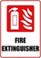  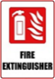  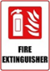  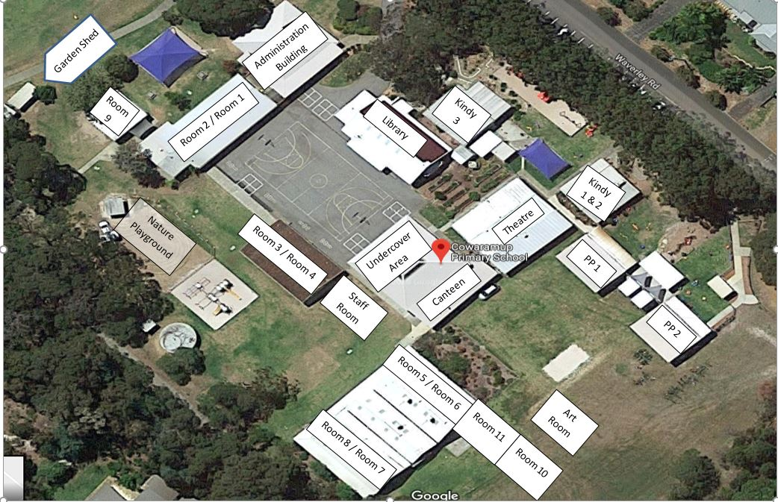 | Emergency Dial 000  Primary action:  Determine if the bushfire is a threat to the school. Monitor official sources listed in section 2.  Secondary action:  Refer to Appendix B for the procedures to Relocate to onsite ‘safer building location(s).
Rooms 1-4
Stay within Classrooms
Red Block
Rooms 5,6,7,8,10,11, Art Room
Library
K1-K3, PP1, PP2, Theatre, Room 9
Administration

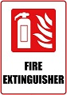  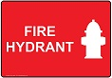 | Map last updated:  July 2020

Offsite evacuation locations
Cowaramup Hall
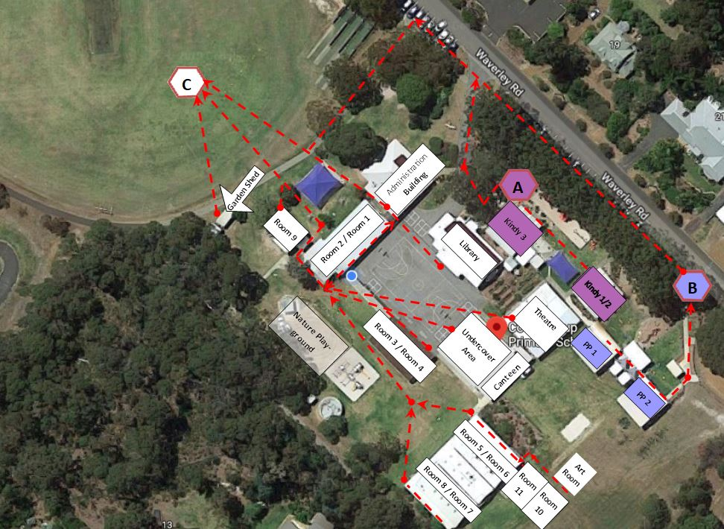 | Emergency Dial 000  Primary action:  Determine if the bushfire is a threat to the school. Monitor official sources listed in section 2.  Secondary action:  Refer to Appendix B for the procedures to Relocate to offsite evacuation location
Cowaramup Oval - Location 1

Cowaramup Hall – Location 2

Map last updated:
July 2020

Bushfire mitigation management register
Attach your bushfire mitigation register for any treatment works or actions undertaken to reduce risk (refer section 3.2 of the Principal’s guide)
Note:
If your school has not received a bushfire risk assessment and treatment plan and had the identified works undertaken, you are not required to complete this register.
Reference number | Bushfire mitigation actions | Target date for completion | Responsible | Source of funds | Notes | Completion date
DFES map item reference | Treatment strategy / works required | Date  (dd/mm/yyyy) | The staff member name who will sign off the action as complete | eg school or central funding | Progress or issues associated with the work (including date of progress or issues) | Date  (dd/mm/yyyy)

Advice from Department of Fire and Emergency Services and other agencies
Record in the table below any bushfire advice received by the school from:
- Department of Fire and Emergency Services, including the local DFES regional office
- local fire brigades and community emergency services manager
- local government
- local government local emergency management committee
- external experts.
Identify the date and source of the advice.
Date of advice | Agency  name | Advice received | Name of officer (who provided advice) | Contact number or email address

Appendix A – Bushfire warnings stages
Issued by the Department of Fire and Emergency Services and Department of Biodiversity, Conservation and Attractions – Parks and Wildlife Service.
Emergency services communicate information in a number ways during a bushfire event. Use these warnings to understand when your need to activate your bushfire procedures (refer to Appendix B).

Bushfire warning stages

1 |  | A fire has started but there is no known danger.  This is general information to keep principals informed and up to date with developments.  Principals must:  - turn off evaporative air conditioners and ensure roof vents are closed.  - check and patrol school regularly for bushfire activity, paying special attention to the evaporative air conditioners.
2 |  | There is a possible threat to lives and property. Conditions are changing.  Principals must prepare to:  - evacuate  - or  - move students, staff and visitors to their pre-determined onsite ‘safer building location’. They must not be moved to an open area.  Evacuation orders are:  - issued by emergency services if required.  - relayed via a variety of official sources such as the DFES website and Emergency WA website.  It is vital that the principal:  - accesses bushfire information from official sources.  - makes an informed decision to stay on-site or evacuate offsite based on advice from emergency services.
3 |  | A school is in danger as its area will be impacted by fire. Take immediate action to survive.  Principal will be advised whether staff, students and visitors can leave the area or if they must shelter where they are as the fire burns through the area.  An emergency warning may be accompanied by a siren sound called the Standard Emergency Warning Signal (SEWS).  Evacuation orders are:  - directed by the emergency services  - relayed via a variety of official sources, such as the Bushfire warning system, DFES website and Emergency WA website.  It is vital that the principal:  - accesses bushfire information from official sources  - makes an informed decision to stay onsite or evacuate offsite based on the advice .
4 |  | The danger has passed and the fire is under control, but stay alert in case the situation changes.  It may not be safe to return to school yet.

Appendix B – Procedures in event of a sudden bushfire

Relocate to onsite ‘safer building location(s)’
You may be instructed to relocate to your onsite ‘safer building location(s)’.
Initiate the below procedure if the following occurs:
- a ‘Watch and Act’ or ‘Emergency Warning’ alert is issued on the Emergency WA website or the Department of Fire and Emergency Services Bushfire Warnings page of the Department of Fire and Emergency Services website (refer to Appendix A for details about the alerts); and
- instruction from the Department of Fire and Emergency Services, Emergency Services or your Regional Executive Director.
Follow these procedures to relocate to the onsite safer building location(s).
Action | Notes (if required)
Dial 000 for emergency services and follow advice.
Remain in contact with the Department of Fire and Emergency Services and monitor official bushfire information sources shown in section 2.1.

Activate your incident management team to carry out their responsibilities (refer to section 3).

Use your emergency response contact list to contact stakeholders (refer to section 2).

Follow your bushfire response telephone call tree to communicate with the school community.

Ensure parents receive emergency text message alerts to:
- inform them of relocation
- keep them updated (use the emergency text message alert templates).

Note: Parents must not collect students until instructed.

Confirm:
- evaporative air conditioners are turned off
- all building roof vents, windows and doors are closed before anyone enters the onsite safer building location(s).

Take emergency equipment (refer to section 5):
- registers for students, staff and visitors
- evacuation kit
- mobile phones (charged).
Sound school emergency warning or alert system.

Follow advice from the emergency services, the Manager, Security and Emergency Management or the Regional Executive Director to move to the onsite safer building location(s) (refer to section 7.1 for map)

Note: Students and staff must remain in classrooms unless they are directed to move to an onsite safer building location.

Check student, staff and visitor registers after moving to an onsite safer building location (roll call). Advise the police if anyone is missing.

Note: You must give special consideration to students with known respiratory conditions.

Update the emergency services on the location of students, staff and visitors.

Wait for the emergency services to arrive or provide you with further information.
Ongoing advice will also be provided by the Manager, Security and Emergency Management or the Regional Executive Director.

Continue to monitor official bushfire information sources shown in section 2.1.

The Department will consult the emergency services and notify you when it is safe to return to classrooms or for students to be collected by parents. You will receive advice from the Regional Executive Director.

Offsite evacuation procedures
You may be instructed to relocate to your offsite evacuation.
Initiate the below procedure if the following occurs:
- ‘Watch and act’ or ‘emergency warning’ bushfire warning alert on the Emergency WA website or the Department of Fire and Emergency Services Bushfire Warning system is invoked (refer to the bushfire warnings listed in Appendix A); and
- Direction from Department of Fire and Emergency Services or Emergency services to evacuate offsite; or
- Direction from the Deputy Director General Schools or the Manager, Security and Emergency Management. The Regional Executive Director will relay the decision to you to evacuate offsite.
Follow these procedures if you need to evacuate to an offsite evacuation location during a bushfire event.
Action | Notes (if required)
Dial 000 for emergency services and follow advice. Remain in contact with Department of Fire and Emergency Services and your Regional Executive Director. Monitor official bushfire information sources shown in section 2.1.

Activate your incident management team to carry out their responsibilities (refer to section 3).

Refer to the ‘emergency response contact list’ to contact stakeholders (refer to section 2).

Follow advice from the emergency services or the Manager, Security and Emergency Management or the Regional Executive Director to decide which of the school’s offsite evacuation location(s) is the safest to use (refer to section 7.2).

Identify an assembly area where staff, students and visitors can gather to prepare for offsite evacuation.

Note: Students and staff must remain in classrooms unless they are directed to move to an onsite safer building location and/or onsite assembly area.

Follow the ‘bushfire response telephone call tree’ to communicate with the school community.

Ensure parents receive emergency SMS alerts to:
- inform them of relocation
- keep them updated (refer to emergency text message alert templates in Appendix C).

Note: parents must not collect students until instructed.

Confirm:
- evaporative air conditioners are turned off
- building roof vents and doors are closed.

Take emergency equipment (refer to section 5):
- registers for students, staff and visitors
- evacuation kit
- mobile phones (charged).
Sound school emergency warning or alert system.

Move all students, staff and visitors from the assembly area to evacuate offsite.

Check registers after evacuating staff, students and visitors (roll call). Advise the police if anyone is missing.

Update the emergency services incident controller on location of students, staff and visitors.

Wait for emergency services to arrive or provide further information. The Manager, Security and Emergency Management or the Regional Executive Director will provide ongoing advice. Continue to monitor official bushfire information sources shown in section 2.1.

The Department will consult the Emergency Services and notify you when it is safe to return to classrooms or for students to be collected by parents. You will receive advice from the Regional Executive Director.

Appendix C - Pre-emptive (planned) closure procedures
You may be instructed to pre-emptively close your school due to a predicted catastrophic fire danger rating.
Initiate the below procedure if the following occurs:
- Alert received from the Department of Fire and Emergency Services; or
- Direction from the Deputy Director General, Schools or the Manager, Security and Emergency Management. The Regional Executive Director will relay the decision to you.
Follow these procedures for a planned school closure in response to predicted catastrophic fire conditions. Also refer to the Flow chart – Principal’s response to catastrophic fire danger rating below.
Action | Notes (if required)
Monitor official bushfire information sources shown in section 2.1.

Activate your incident management team to carry out their responsibilities (refer to section 3).

Use your emergency response contact list to contact stakeholders (refer to section 2).

If it is safe and there is no active fire in the region, two nominated staff members (usually the Principal and one other staff member) attend school from 8.00am to 10.00am on the day of pre-emptive closure. They:
- inform community members of the school closure
- secure the facility and activate the electronic security system when leaving (only if it is safe to do so) the site at 10.00am.

Communicate the pre-emptive closure, continued closure or school reopening:
- follow the bushfire response telephone tree (refer to communication templates in Appendix C)
- place the notice of temporary closure on external school access points and on the school website
- use social media channels to keep the school community updated.

Note: Contact lists for staff and parents must be current.

Confirm:
- windows and doors are closed
- evaporative air conditioners are turned off
- roof vents closed
- money is removed from the school premises
- expensive items of equipment secured.

Secure school premises and activate security system. Before departing, email AssetPlanningServices.SecurityEM@education.wa.edu.au or call 9264 4632 to confirm:
- all security systems armed
- site is secure.
Remove the notice of temporary closure from external school access points if pre-emptive closure is reversed.

Flow chart – Principal’s response to ‘catastrophic’ fire danger rating

Appendix D – After hours or school holiday procedures
You may be instructed to keep your school closed during the school holidays or after hours during a bushfire event.
Initiate the below procedure if the following occurs:
- ‘Watch and act’ or ‘emergency warning’ bushfire warning alert on the Emergency WA website or the Department of Fire and Emergency Services Bushfire Warning system is invoked (refer to the bushfire warnings listed in Appendix A); and
- Direction from the Deputy Director General, Schools or the Manager, Security and Emergency Management. The Regional Executive Director will relay the decision to you.
Follow these procedures if a bushfire starts during the school holidays or after hours.
Action | Notes (if required)
Remain in contact with your Regional Executive Director and monitor official bushfire information sources shown in section 2.1.

Use your emergency response contact list to contact stakeholders (refer to section 2).

Follow the bushfire response telephone call tree to communicate with the school community.

Send parents and staff emergency text message alerts to inform them of the school closure (refer to emergency text message alert templates in Appendix E).

Work with the Regional Executive Director to seek alternative school and transport arrangements (if required).

Department Media Unit uses media outlets to make public announcements of:
- the school closure
- temporary alternative accommodation.

The Department will consult the Emergency Services and notify you when it is safe for the school to reopen. You will receive advice from the Regional Executive Director or the Manager, Security and Emergency Management.

Send parents and staff emergency text message alerts to inform them when school can reopen (refer to emergency text message alert templates in Appendix C).

Appendix E – Communication templates

Emergency text message alert templates
You can use these sample text templates update parents, carers and staff about a response to a bushfire. These texts are also located on Ikon – refer to Manage bushfire and emergency incident communications.

Public schools to close tomorrow due to catastrophic fire danger rating

[School name / all public schools in region/area] will be closed tomorrow [date] due to a catastrophic fire danger rating for the area. See emergency.wa.gov.au/#firedangerratings for more information. There will be no staff on site. Please ensure that you make arrangements for your child.

Students are safe and still on school site

Students from [school name] are safe and being supervised at school. We will follow the instructions of emergency services and update you if the situation changes. Monitor emergency.wa.gov.au or call your education regional office on [telephone number] for more information.

Students have been relocated

Students from [school name] have been relocated for their safety. Please collect your children from the relocation centre at [exact location]. Follow the instructions of emergency personnel and monitor emergency.wa.gov.au or call your education regional office on [telephone number] for more information.

Not safe to pick up children

Students from [school name] are safe and [are still on school site / have been relocated for their safety]. Please wait for further instructions before attempting to collect your child. We are working with emergency services and will advise when it is safe to do so. Monitor emergency.wa.gov.au or call your education regional office on [telephone number] for more information.

School to reopen on [day]

[School name] will reopen tomorrow/day [date].

School newsletter sample text
You can use this sample text below can be used to provide the school community with information about a pre-emptive closure.

Pre-emptive (planned) school closure during the bushfire season
[School name] has been place on the Department of Education bushfire zone register as it is located in a designated bushfire risk area.
If a ‘Catastrophic’ fire danger rating has been declared for the [City/Town/Shire] of [ name of your school’s local government area], the school may be required to invoke a pre-emptive (planned) closure. A ‘Catastrophic’ fire danger rating poses a significant threat to the school as if a fire starts, it is likely to be uncontrollable, unpredictable and fast moving.
Parents will receive a text message to inform them of a possible Pre-emptive closure of the school.
The final decision to pre-emptively close the school will be confirmed with the principal no later than 4.30pm on the day before the pre-emptive closure. If the forecast changes after the 4.30pm deadline, the school remains closed to limit confusion within the school community.
Parents will receive a text message to either confirm or reverse a Pre-emptive closure of the school.
Typically, schools will only be required to close for a day at a time. However, this will depend on changing weather conditions. Parents will receive a text message to advise if the school will reopen the day after the pre-emptive closure, or whether it will remain closed.
Parents are encouraged to monitor official bushfire information sources for current information about fire danger ratings:

- Emergency WA website - https://www.emergency.wa.gov.au/

- Department of Fire and Emergency Services
Information line – 13 33 37
Twitter - https://twitter.com/dfes_wa

- Local radio
- ABC Emergency WA
- ABC local radio
- 6PR
Please contact the school on <school phone number> with any concerns relating to Pre-emptive closures during the bushfire season.
[Name]
Principal

Sample text for a notice of temporary school closure
The sample text below can be used in a notice to be placed on:
- the school main notice board at front of the school
- main administration entrance doors
- other entry/exit doors throughout the buildings
- kindergarten and pre-primary, where relevant.

BUSHFIRE ALERT

NOTICE OF TEMPORARY SCHOOL CLOSURE

As the result of a ‘Catastrophic’ fire danger rating, this school is temporarily closed.
The school will re-open on advice from the Department of Fire and Emergency Services (DFES).
For more information about the bushfire threat:
- call 13 DFES (13 33 37)
- visit www.dfes.wa.gov.au and Emergency WA
- stay tuned to ABC local radio.
For more information about the school, contact the principal on [insert contact details] or the [insert region] regional education office on [insert contact number].
Thank you.
[Name]
Principal

